11/22/07

Ambassador Agriculture & Animal Health Program...

Exciting Discoveries
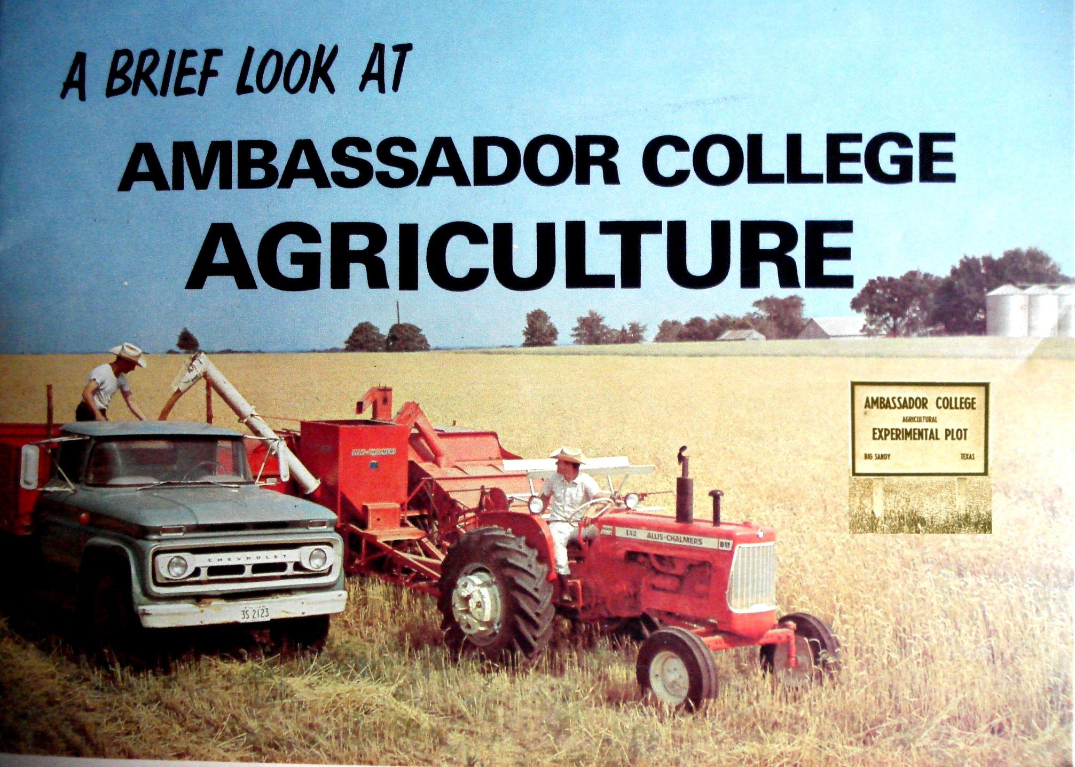

By: Allen L. Stout, DVM

The Ambassador Agriculture Program began in Big Sandy, Texas in 1964. This is a brief summary of my experience and some of the opportunities, goals and exciting discoveries in understanding practical, sustainable, biblical and scientific agricultural principles that were made as a result of the program.
I had been teaching science and health classes at Ambassador College in Pasadena, California in 1967 when I was transfered to the campus in Big Sandy, Texas to work in the agricultural program as the college veterinarian.
Because of the high quality and standards I was familiar with at the Pasadena campus, I was expecting something like a southern plantation in Big Sandy, but was shocked to see...land so poor and eroded that it would hardly grow weeds, fences broken down and rusted away and some of the poorest looking cattle I had seen anywhere with many disease and parasite problems. I tested the cattle herd for brucellosis and 15 were reactors and had to be condemned. I had asked the State veterinarian for permission to keep them for research purposes, but was denied.
I was somewhat perplexed with what I saw. And knowing that God owns the world (Ex 9:29; Deut 10:14; Psa 24:1; 50:12), I wondered why He gave us this, since the college was sponsored by the Church of God.
I saw that the Bible says we shall inherit the earth (Psa 37:9 & Mat 5:5), but it also says the earth is being corrupted, and that we will inherit the desolate heritages. (in Lev 26:33-35; Isa 6:11; 49:8; Jer 4:27; 12:10-11; Zech 7:14, etc). So it appeared that God was giving us our first piece of a desolate earth to learn what men were doing to it.
Then Acts 3:21 says there will be "times of restoration of all things..." when Christ returns. I perceived that our job was to learn to restore our first piece of a desolate earth, so we could teach His ways to the world in the future when He returns to reestablish the Kingdom of God on the earth (Psa 67:1-7; Mat 4:17; Rev 11:15).
The motto of Ambassador College was to "Recapture True Values." Our goal was to learn how to restore this land - the soils, crops, animal health, fences, etc. doing it God's way (Isa 28:9-10,16,23-29).
Before going to Ambassador College I had been in veterinary practice, had taught Veterinary Pharmacology & Therapeutic Medicine at Iowa State University Veterinary college, and had been an Assististant State Veterinarian in Oregon in the Disease Control & Eradication Program. But in all that I learned that man's ways and medicines weren't solving the problems, they were mostly just treating the effects. I didn't think that God wanted me to be shooting His animals with all kinds of drugs, so repented of that approach, though some expected me to pull magic potions out of my bag to cure all these diseases.
So what was I supposed to do?
The Ambassador ag program was trying to apply organic practices, but at that time "organic" was more of a religious philosophy and highly anti-science. I was trained in scientific principles and felt the need to apply basic scientific principles to prove what we were doing.
Mr. Dale Schurter, chairman of the Agriculture Department, was a super-salesman for the ag program. I think my job was to keep it credible and make it work.
As I was managing some of the programs and ran the dairy operation, feeding and milking the cows, shoveling manure, building fences, etc., I focused on correcting animal health problems through selective breeding for stronger animals and culling the weak as Jacob did (Gen Gen 30:27-43 - see heading "Genetics of Health & Disease"), and improving nutrition through feed testing, balancing rations, and formulating supplements to supply deficient nutrients, and building fences and rotating pastures to get cattle out of pens and onto cleaner ground, and treating specific health problems when necessary mostly with natural remedies (see Animal Nutrition & Health Program).
But the so-called organic fertilizer program was causing some major animal health problems. The whole dairy herd came down with varying degrees of severe vitamin-A deficiecy syndrome caused by toxic nitrates - I had treated plenty of cattle for nitrate toxicity while in practice after N fertilizers became popular. All the cows had pink-eye, some blind in both eyes, so I had to lead some in and out of the milking barn and feed them by hand. Calves were born weak and some died.
That's when I got involved in the soil program to find out what they were doing that was causing the problems, and began testing soils and feeds for deficiencies and toxicities. I went to the County agent, the Texas A & M Experiment station in East Texas, the State Soils lab and to the National Fertilizer Development Center in Muscle Schoals, Alabama.
I had wondered why our national fertilizer programs were only supplying N-P-K (N = nitrogen, P = phosporus, K = potash or potassium) fertilizers when plants need at least 16-21 elements. I learned at the National Fertilizer Development Center that it was originally the Army Munitions Development Center working on technologies for producing N-P-K explosive ammunition chemicals used for war. After the war it's purpose was changed to show how to use these same chemicals, N-P-K, on farms to enhance production, and thus keep these chemical industries in business. Much money was given to ag colleges to set up demonstration plots in each state to promote their use.
The results of Texas State Soils Lab tests were inadequate because they were geared mainly to promoting the use of N-P-K fertilizers, so I sent samples to U.S. Testing, a national lab in Memphis and determined the cause of the problems, and later to Brookside Farms Labatory Association in Ohio.
Our ag department had been using a natural mined, supposedly organic, fertilizer called Chilian nitrate to fertilize one of my dairy pastures. The grass greened up, but the sandy soils were so deficient in sulfur and other elements that the nitrates couldn't be converted to proteins in the plants and accumulated in toxic forms, which then caused the severe vitamin-A deficiency syndrome in the dairy animals.
Then we began a restoration program to rebuild the depleted soil minerals using truck loads of rock phosphate, lime and other natural minerals to build and balance the soils. We also grew and applied soil microorganisms to the soil and used legume crops to capture free N from the air (see Keys to Understanding Soil Testing...For Sustainable Soil Management).

The Land Sabbath
We studied and kept the land Sabbath in 1972-73 in Big Sandy, Texas and were blessed with rains in due season and saw many other benefits including improved soil fertility, renewed health and productivity of our livestock, etc. (Lev 25:1-12,19-22; 26:3-5; Deut 28:1-5,11-12 - see Keeping the Sabbath & Jubilee Years...For a Prosperous Sustainable Agricultural Economy).
The results of our program were so fantastic on improving the productivity of the land and on the health of the livestock that many in the East Texas area took notice... Where before we had to buy hay to feed the livestock, now the pastures were so productive we were able to cut and put up hay while the cattle grazed.
In 1974 we put on a joint seminar on campus for cattlemen with Texas A & M Experiment Station scientists, and I presented the results of our research, and the Texas A & M scientists presented their research. Because chemical fertilizer costs were spiraling upward, our program cost about 1/3 that of Texas A & M. Afterward ranchers crowded around us asking questions about our program.
Those were exciting times - we also discovered a lot of other interesting things thanks to God's help (Psa 25:8-14).

Genetics of Health & Disease
It would be remiss to ignore the factor of genetics in plant and animal productivity and health and resistance to disease, for God has given specific knowledge and instruction in His written Word, the Bible, concerning this. In Leviticus 19:19 it says,
"You shall keep My statutes. You shall not let your livestock breed with another kind. You shall not sow your field with mixed seed."
The principle began with the creation of the various genetically different kinds of plants and animals in Genesis when God said (commanded):
"Let the earth bring forth ("dasha," to sprout, bring forth) grass ("deshe," a sprout, grass, tender herb), the herb yielding seed, the fruit tree yielding fruit after its kind, whose seed is in itself, upon the earth; and it was so.
"And the earth brought forth grass, the herb that yields seed according to its kind, and the tree that yields fruit, whose seed is in itself according to its kind. And God saw that it was good...
"And God commanded, Let the waters bring forth an abundance of living creatures, and let birds fly above the earth in the firmament (space or sky) of the heavens.
"So God created the great sea creatures and every living creature that moves, that abounded in the waters, according to their kind, and every winged bird according to its kind. And God saw that it was good" (Gen 1:11-12, 20-23).
We began selecting pure seeds of high quality natural plant varieties rather than crossed or hybridized seed varieties and selecting and breeding quality purebred livestock varieties, which reproduce "after their kind," in compliance with God's instructions.
Crossed or hybridized plants do not produce pure seeds "after their kind" and therefore one cannot save seed from his crop, but they must buy seed from the seed companies that do the hybrid crossing. In the past farmers kept their own seed selecting from the best most hardy high quality plants, thereby developing heirloom seeds best adapted to their own area and land. Seed companies cross and select hybrids that respond best to the chemical farming programs. When farmers began switching to hybridized seed, they also had to use the chemicals they were selected and adapted for. And when they no longer had their own seed to fall back on, the cost of seed skyrocketed - ie. instead of saving one's own corn seed worth say $3/bushel, costs for seed may now cost over $60/bushel. And now seed companies are going the next step of genetic engineering of plants making farm producers even more dependant on them and the hugh financial, chemical, industrial complex.
The results of hybridizing and genetic engineering of our plants and chemical farming programs has also had a major effect of food quality and health (see Food Quality & the Health Crisis). For example, the nutritional quality of grains such as corn and wheat have gone down significantly since the introduction of these programs. Average protein values of corn in the 1920's were approximately 12% and for wheat approximately 18%. Average values for corn then gradually dropped to 6-8% and for wheat to about 12% and some of the essential amino acids, such as lysine, have become major deficiency problems.
In setting up and consulting on soil fertility test plots with seed companies in the 1980's we found that hybrid plant varieties could out-produce (in yield but not quality) natural purebred varieties on the chemical programs, because the purebred varieties required more complete and balanced soil fertility to produce high yields of high quality. But on highly fertile balanced soils the purebred plants out-produce the hybrids.
In breeding livestock, the Scriptures warn against two extremes - close intensive inbreeding (the principle in humans applies to animals - Lev 18:5-14); and crossbreeding of different kinds or varieties (Lev 19:18). As a student in Veterinary college I worked on a project with the Animal Science Department studying dwarfism in cattle, which is one of the results of close inbreeding. In veterinary practice I did many hernia surgeries on calves and pigs that were defects resulting from close inbreeding. Many genetic problems are common from inbreeding of small animals - such hip dysplasias in German Shepherd dogs.
Crossbreeding of dissimilar varieties of animals sometimes produces hybrid vigor in the offspring, but also produces mongrels, and the offspring then produce unpredictable qualities in future generations. As a veterinarian, I have seen and have nearly been killed by crossbred cattle with volatile and dangerous temperments.

The Curse of Weeds
Why did God create weeds, thorns and thistles? What could be good about them? Did God create them to be a curse? God said to Adam:
"Because you have heeded the voice of your wife, and have eaten from the tree of which I commanded you, saying, 'You shall not eat of it':
"Cursed is the ground for your sake ("abuwrekaa," the correct meaning here is 'because of you'); In toil you shall eat of it all the days of your life.
"Both thorns and thistles it shall bring forth for you, and you shall eat the herb of the field.
"In the sweat of your face you shall eat bread till you return to the ground..." (Gen 3:17-19).
As I said before, our land was so poor, it would hardly grow weeds, but some did grow. I had never heard of burr-grass before going to Big Sandy. Cockle-burrs and thorns and thistles were prevelant. The land had been badly abused years before under continuous cotton. A neighboring farmer, who was 76, told me that, "When they were growing cotton here in the 1930's, that piece of land you have wouldn't grow cotton a foot tall. It was the worst ground around."
A correct translation and understanding of Genesis 3:17-19 does not say that God cursed the ground for man's sake, as many assume, but that the ground would be cursed "because of man," - that is because man wouldn't obey God's instructions on how to care for it properly and would not keep the land Sabbath (Gen 2:15; Lev 25:1-12,19-22; 26:32-35 - see "Conquest of the Land through 7,000 Years", "Ill Fared the Land" & "Food & Agriculture...A Growing World Crisis").
Thorns and thistles, weeds, grow on poor land and were created to provide a cover to prevent erosion and restore the land. Most weeds are hardy, deep rooted and resist drouth, are often bitter and toxic, some having thorns and thistles making it less likely that animals would graze them down and denude the soil surface. Weeds bring up minerals from the subsoil and add organic matter to form topsoil. Food and feed crops require more fertile soils than weeds to thrive and compete and produce good yields of nutritious foods. But instead of correcting the problems of soil fertility, men are treating the effects by developing and using chemicals (herbicides) to kill the weeds. But herbicides also cause damage to food crops and sometimes make them toxic, and this does not correct the underlying problem of declining soil fertility.
On test plots we (later in my consulting business) set up on farms in many states we found that food crops will out-compete weeds in fertile soils, but weeds will thrive better in soils that are deficient and chemically and biologically imbalanced. Scientists at Washington State University found that crops such as wheat produce natural herbicides that inhibit weeds, but as soil fertility declines weeds take over.
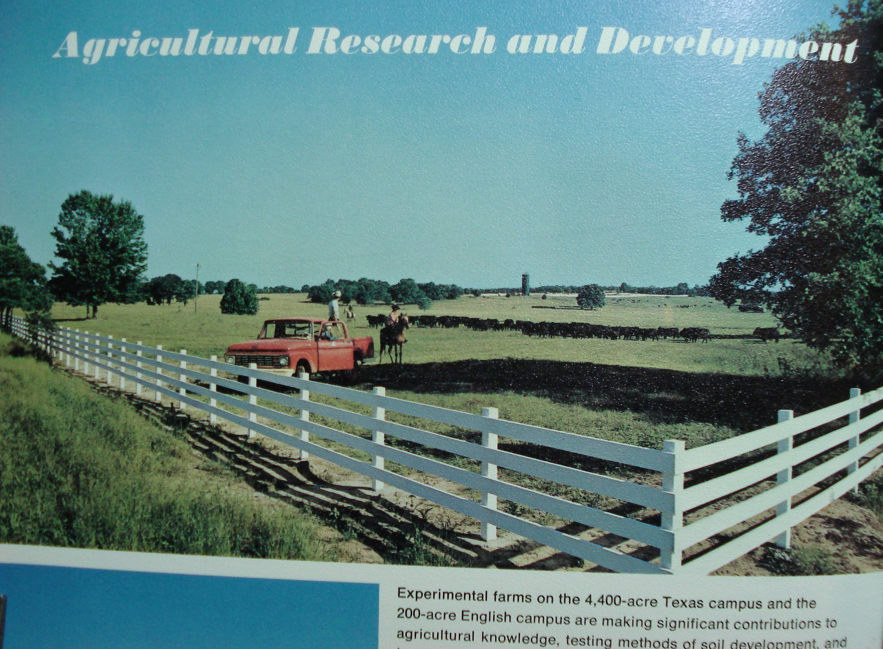
We set up a 10 acre test plot in the Ambassador Agricultural Research Program comparing Texas A & M fertilizer recommendations with our approach. Just before harvesting I was in our office, a metal building, and heard a hail storm hit. I feared we would lose all that work, and got on my knees. Shortly after, a ranch hand came in and said, He saw an amazing thing. When the hail began He was driving on the ranch and when he came to the test plots the hail stopped, and when he passed, it started again. When we harvested the plots later the results of our program showed a hugh difference in quality and production at much less cost compared to the chemical program recommended by Texas A & M.
Gen 1:31 says, "God saw every thing that He had made, and, behold, it was very good." When I first came into the church, I read that and asked, "What's good about all these insects, parasites and disease organisms that I had to learn about in Veterinary college?"

What's Good about Insects, Parasites & Disease Organisms?
I began to learn that ALL microorganisms are beneficial and essential. It would take volumes of books to describe all the benefits we derive from them, even our antibiotics come from soil mircrorganisms. Less than 1% of all microorganisms cause disease, and they become pathogenic only under certain conditions, which can be controlled or corrected when we follow God's instructions (Lev 26:3-6,14-16,20,34-35; Deut 28:1-4,15-22). Insects, diseases and parasites only become problems when soils, plants and animals are not healthy because of nutritional deficiencies, toxicities or other factors.
So, what causes microbes and other organisms to go beserk and cause disease?
In one example, e. coli, which has been incriminated in many animal and food-borne disease outbreaks, is normal in the gut of every animal and human, and normally produces beneficial enzymes and nutrients including amino acids, vitamins, etc. When we culture the microorganisms in the lab, we could tell whether they were in a normal non-pathogenic state or in a pathogenic state by the way they grew on the culture plates - a rough colony is normal and a smooth colony is pathogenic and produces and accumulates toxic amines. Toxic amines are precursors of amino acids and normally are converted to amino acids by the mircobes, but in conditions of deficiencies the amines may not be converted to beneficial amino acids and accumulate as toxins - much as excess N accumulates in crops in toxic forms under certain conditions, such as when plants are deficient in sulfur or other essential nutrients - as happened in my dairy pasture.
While working with the Oregon State Disease Control & Eradication Program I investigated a problem in eastern Oregon where ranchers were loosing millions of dollars from calf scours, some caused by e-coli. I found there was usually a direct nutritional link showing up on soils deficient in copper or other elements. Later in Texas I learned to treat these problems with nutritional supplements with excellent results.
Also while investigating persistant brucellosis problems in some Oregon dairies, where even vaccinated animals were breaking with the disease, I found a nutritional link with magnesium deficiency, which when corrected elimnated the problem. An optimum magnesium level in the blood is essential for the natural blood antibodies to work because it is a compliment in the antibody-antigen reaction, as shown by research published in a Veterinary Research Journal.
Remember also some years ago the tampon toxicity syndrome that killed many women? They discovered that the material the tampons were made of was absorbing the magnesium out of the serum in the vagina and allowing bacteria to grow producing the toxins. When they changed the material they stopped the problem.
I found that calf scours and other diseases, such as brucellosis, could be prevented or corrected by nutritional supplements, such as Mg, S, Cu, Zn, etc. when they were deficient. For example I traced some scour problems directly to copper (Cu) deficiency) and others to sulfur (S) deficiency, which were corrected with proper supplementation. When we had the brucellosis problem at Big Sandy, I began adding magnesium to the supplement for the cattle and corrected the soil deficiency and we never had another problem even though we didn't vaccinate the cattle and brucellosis was a major problem in Texas.

What About Insects?
Besides pollinating our crops and collecting honey for us, what's good about insects, especially those that eat up our crops or bite on us and our animals? Our research and observations revealed that insects eat plants that are deficient or toxic, and not fit as food for us or our animals. Therefore, it seemed apparent that God had created insects that eat our crops and bite our animals and us to be inspectors checking our plant and animal health. Tests showed that insect and disease damage was greatest when plant energy levels (sugar production) was low because of nutrent deficiencies or toxicities (most often excess N from fertilizer) and healthy plants and animals were unaffected by parasites, insects or disease organisms.
We cleared several hundred acres of bottom land and fertilized and planted it to grass. The grass came up and looked great, then one day one of the ranch hands reported that it was being eaten up by army worms, a big problem in Texas. I took my ag research class out to investigate the problem and we found spots in the field and the ends of the field where the army worms were crawling through but not eating the grass. Tests revealed these areas were 2-3 times higher in Phosphorus (P), an essential part of the energy transfer molecule ATP, because the spreader trucks dumped more rock phosphate when turning around at the ends of the fields and on spots where they got stuck.
Dr. James Dodd, a plant pathologist in Minnesota, and other scientists discovered that root rot and stalk rot in corn occurred in plants with excessively high N and low potassium and low sugar levels, often in combination with environmental stresses. Dr. Philip Callahan, a USDA entomologist whom I had become acquainted with at Acres USA Agriculture & Environmental Ecology Seminars, discovered that insects were attracted to plants high in nitrates, which are also low in energy (energy/sugars are required in plants to convert N to proteins). In test plots we set up on farms in many states, we observed the same things many times - that plants with excess N and low sugar levels, usually due to other nutrient deficiencies, were most affected by insects and plant diseases, whereas healthy plants were resistant.
At the college dairy, we had a severe horn fly problem biting the cows making it miserable for both the cows and me. Trying to determine why the flys were attracted to the cows I speculated that maybe it could be a sulfur (S) deficiency (I was already supplementing most other nutrients), because the hair and skin were scurfy and skin and hair proteins require high S. So I added a tablespoon of S to each cows feed in the milking parlor and within 3 weeks, their hair coats bloomed out and the flys disappeared, much to the relief of the cows and me. I thought that was interesting, but after a while I quit supplementing the cows with S and within 2 weeks the flys were back. After that S was added to the reqular supplement and became an important part of the fertilizer program solving many problems.
As a result of these and other studies it became clear that insects eat unhealthy crops and were created to be our plant food inspectors, and that microbes, such as beneficial soil saprophytes, cause decay (called diseases such as root rot and stalk rot in growing crops) of weak unhealthy plants as part of a recycling program of "nature". They only eat on plants that are deficient in essential nutrients or toxic and have low energy (sugar) levels. Such deficient plants today often have excess N because of improper use of chemical fertilizers making them toxic and therefore not good nutrition for our animals or us.
Man's way has been to use chemical fertilizers and pesticides, originally developed for war, for growing food and to kill our plant food inspectors and eat the unhealthy food. Then the medical profession attempts to cure the problems by treating the effects with medicines. The chemical and pharmaceutical companies and medical profession would no doubt ridicule concepts I am presenting because they make hugh profits treating the effects of ignoring God's instruction, and because many are ignorant of or disbelieve in the Creator who saw "everything that He had made, and behold, it was very good." (see Mankind's Greatest Experiment)

Natural Treatments and Preventatives
When I took pharmacology and therapeutic medicine in Veterinary school in the 1950's, they still taught "materia medica" - that is the materials of making medicines, which included herbs and nutritional materials. But after big pharmaceutical companies emerged in World War II and after, it was soon no longer taught in medical or veterinary schools, and it is even forbidden by Federal and some State laws for doctors and veterinarians to compound and use their own remedies. But I was able to apply much of that knowledge and experience in preventing and treating animal health problems in the Ambassador agriculture program.
As mentioned above, I formulated various nutritional supplements and also took advantage of various herbal and other materials that had been proven effective in treating various problems. Also I had observed over the years that animals will browse on various herbs to correct their nutrient deficiencies and imbalances. In one case a farmer in Missouri called me for advise on what to do in an outbreak of Blackleg disease, which was killing many cattle in his area on improved highly fertilized pastures including his. They were told to vaccinate their cattle, but I told him it takes about 3 weeks for that to build immunity and it may not work if the animals are defieient or toxic. I told him to turn his cattle out on brushland, which he did. Later he called back and told me his cattle browsed and devoured the brush and he never lost any more, and even one animal that was gravely sick and disappeared, showed up a week later recovered. Whereas the neighbors around who vaccinated continued losing cattle for another 3 weeks or more. In today's "scientific" farming practices most livestock have little chance to browse.
I had met at seminars and become friends with a Norweigen who imported Norweigen kelp. With his prompting I set up Kelp trials on animals and plants. I found, as others before had, that internal parasites and plant nematodes, diseases and insect problems were minimized or disappeared when kelp was added as a nutritional supplement. Kelp is a good natural source of many trace minerals and other factors.
When the agricultural instructor at Imperial Schools in Big Sandy came to me because their sheep were dying from internal parasites, we supplemented them with free-choice Norweigen kelp and they recovered and did well without using any worming medicines. Later in tests in several kennels raising dogs and losing pups from hookworms, we found that after kelp was supplemented, the losses were stopped. Garden tests showed that nematode problems in potatoes and carrots were stopped by adding kelp to the soil. Later, working with Dr. T.L. Senn, a former professor and head of the Horticulture Department at Clemson who had done considerable research on seaweed applications in agriculture, we found in research on farm test plots that foliar applications of liquified kelp on crops stopped aphid and other insect problems as well as increasing resistance of crops to drouth and frosts.

Seedtime and Harvest
In the book of Ecclesiastes Solomon wrote,
"To everything there is a season, a time for every purpose under heaven...
"A time to plant, and a time to pluck (harvest) what is planted" (Eccl 3:1-2).
But who knows the time? He continues,
"In the morning sow your seed, and in the evening do not withhold your hand; for you do not know which will prosper, either this or that, or whether both alike will be good" (Eccl 11:6)
We had many letters inquiring about whether to follow the Farmer's Almanac and practices such as planting by the moon or signs of the Zodiac, especially after an article came out in a church publication seeming to endorse it. Our own studies and experience confirmed Solomon's. Because every area and every year is different, you can't know for sure. But with the right calendar to give one correct knowledge of seasons and times one can learn by experience how to best apply it to their own area and farming program.

Ambassador Agribusiness Degree Program
When Ambassador College decided to offer a major in agribusiness, Dale Schurter and I went down to Texas A & M to council with Dr. Kunkel, Dean of the Ag Dept. and his assistant, Dr. Potts. When we told them we were planning to develop an agribusiness degree program for our students, his comment was, "We already have 23 ag colleges in Texas and don't need any more, what could you possibly offer that isn't already available?" So we explained that we had several thousand acres with dairy, beef, poultry, and equine operations, and crops, gardens, greenhouses, etc. where our students all get practical on-the-farm experience. About that time Dr. Potts was called out on a phone call... When he came back he said, "I've got jobs for 2 of your graduates right now. They want graduates with on-the-farm experience. Our problem is we have a hugh program with over 200 faculty but can't offer on-the-farm experience and training." So they got excited about our program.
Several years Later, in the spring of 1977, we had 2 visitors from India. They said that they had been visiting ag colleges all over the U.S. for the last 6 months looking for a place to send students to learn practical, self-sufficieny, sustainable agriculture. They had just visited Texas A & M and said that Dr. Kunkle said he knew of only one place that had a program like that, and that was Ambassador College in Big Sandy.
After we showed them around and explained our program, they asked, "When can we send students? We would like to send 30 right away, this summer."
Well, the college in Big Sandy and the Ambassador ag program was closed in the summer of 1977, so it never happened. It was not yet time for the "restoration of all things." But we had a foretaste of what it will be like.

Copyright (©): Allen Stout, DVM; 11/22/2007 Serf Publishing, Inc. P.O. Box 65838, Vancouver, WA 98665 - www.serfpub.com or alstoutdvm@aol.com

